|  |  |  |
| --- | --- | --- |
| SCHOOL OF INFORMATION AND TECHNOLOGY | | |
| NAME: Arjay De Leon | DATE PERFORMED:09/25/24 | /50 |
| Section: IDC1 | DATE SUBMITTED:09/25/24 |

# SYSADM1 – Monitoring Print Services in Windows Server 2019

# Requirement:

* A virtual machine running Linux and Windows OS

Part 1: Setting Up Print Services

1. Install and configure **print.srv** domain
2. Connect one client to the recently created domain
3. Install Print Services Role:
4. Search the internet for any printer installer and convert it to iso
5. Install and deploy it as network printer

Part 2: Monitoring Print Services

Objective: Familiarize yourself with monitoring tools available in Windows Server 2019.

1. Event Viewer:
   * Open Event Viewer (run eventvwr.msc).
   * Navigate to Applications and Services Logs > Microsoft > Windows > PrintService.
   * Review logs for print jobs, errors, and warnings.
2. Performance Monitor:
   * Open Performance Monitor (run perfmon).
   * In the left pane, expand Data Collector Sets > System.
   * Right-click System Performance and select Start.
   * Monitor performance metrics related to print services.
3. Using Print Management Console:
   * Open Print Management from Server Manager.
   * View active print jobs and their status.
   * Use the Printers node to check the status of all printers.

Part 3: Exploring Third-Party Monitoring Tools

1. Research at least two third-party print monitoring tools
   * Consider factors such as features, pricing, and compatibility with Windows Server 2019.
2. Install and Configure:
   * Choose one of the tools to install in your environment.
   * Follow the installation instructions provided by the tool's documentation.
   * Configure it to monitor your print services.
3. Test and Report Findings:
   * Generate a report or dashboard from the tool.
   * Analyze the collected data (e.g., print volume, errors, user activity).

Server to client

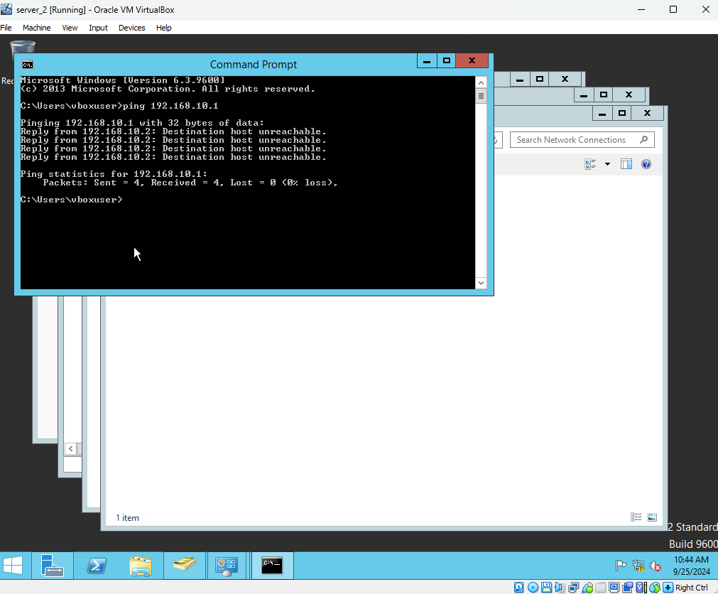

Client to server

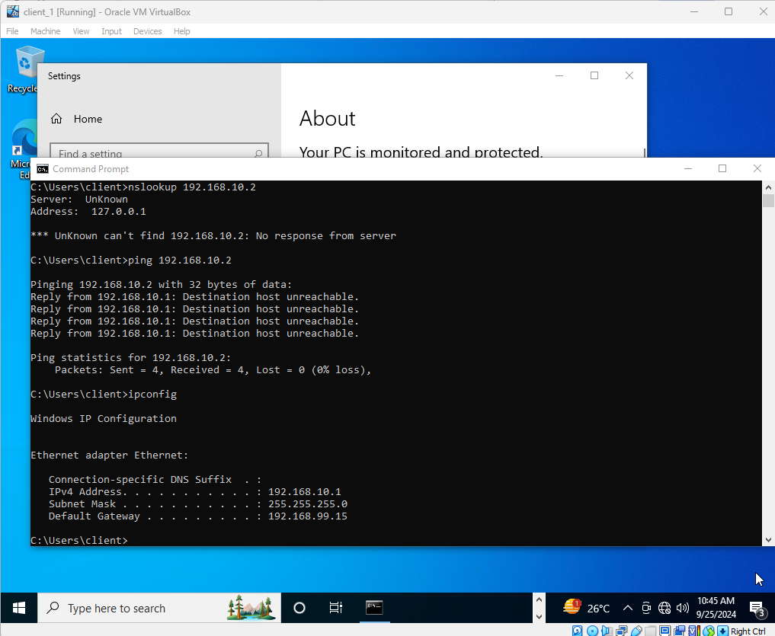

Server ip address

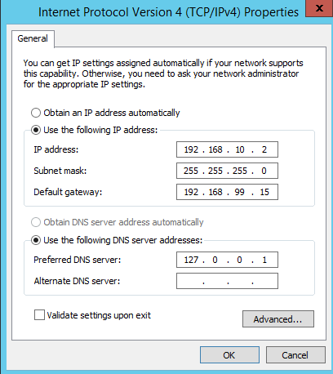

Client ip address

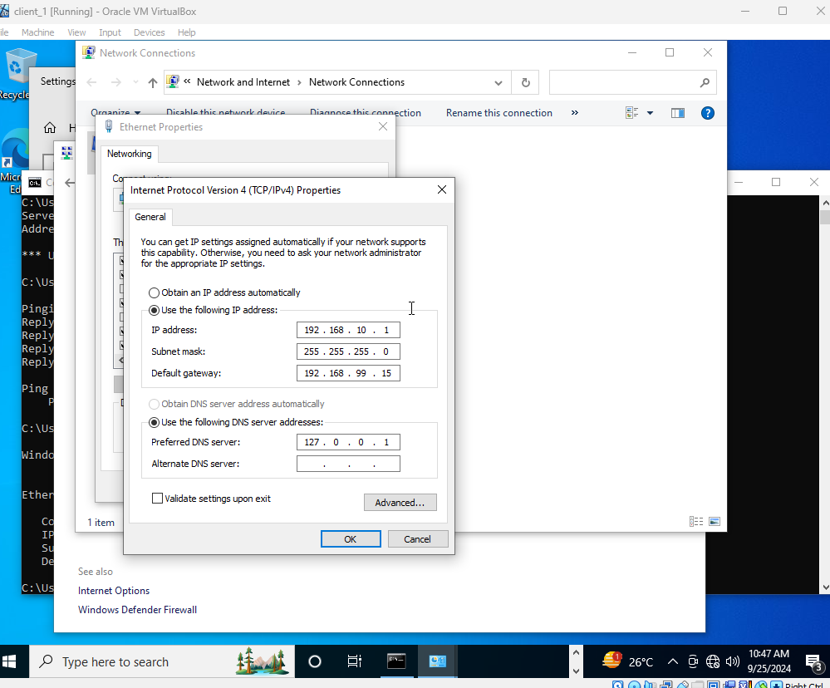

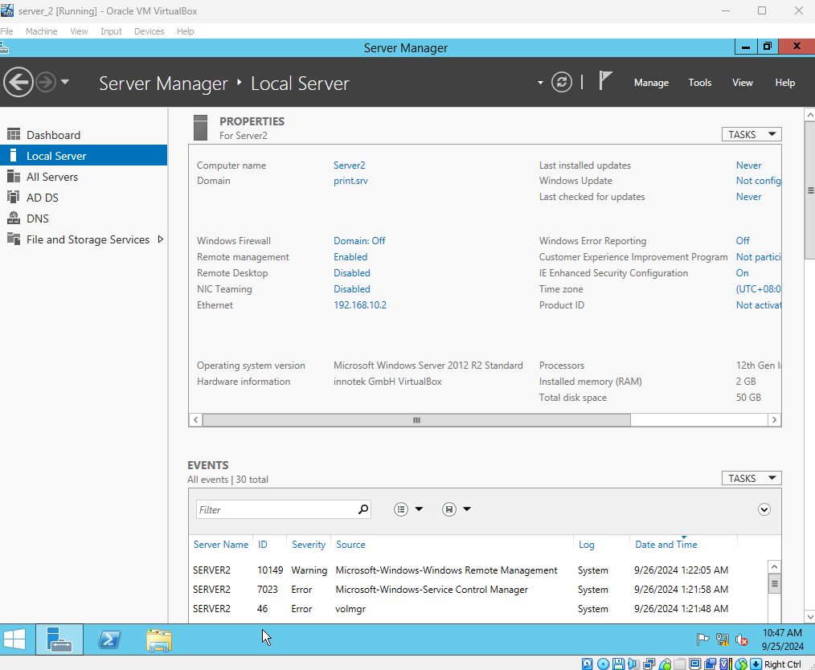

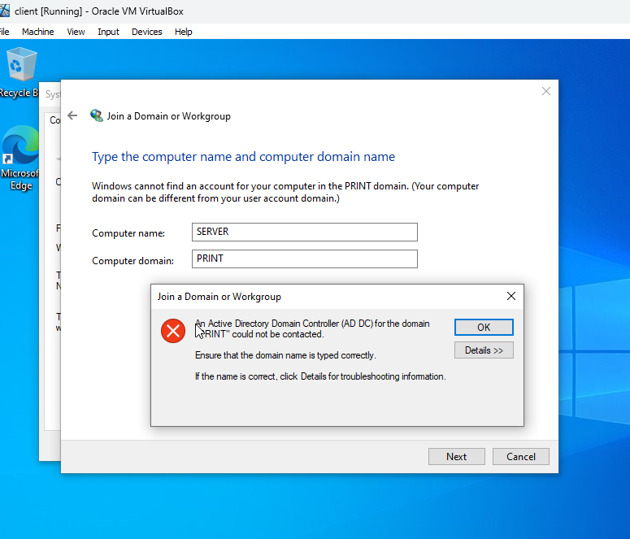

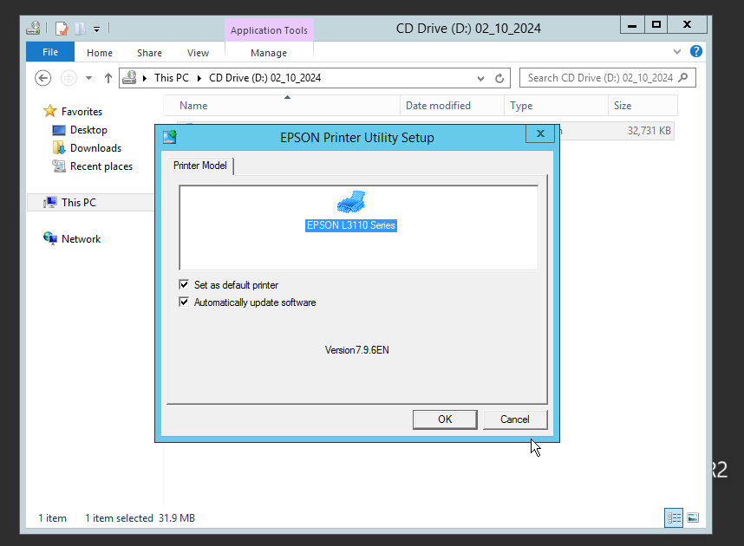

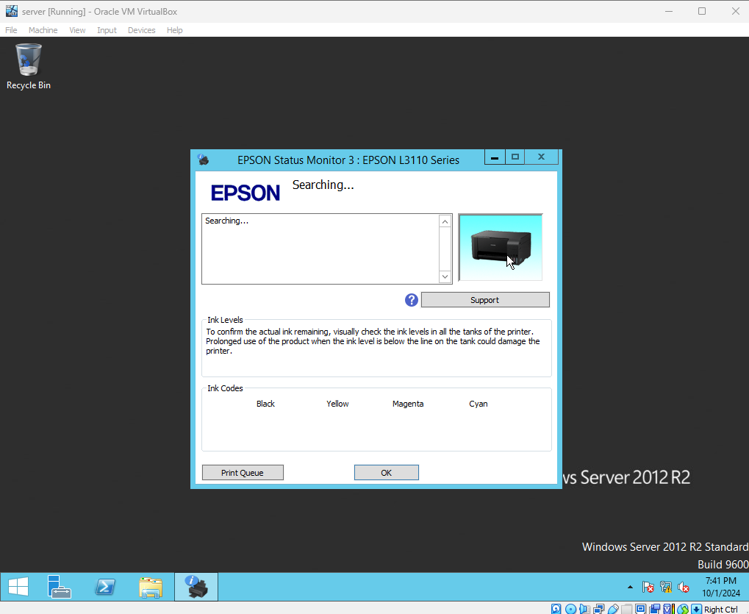

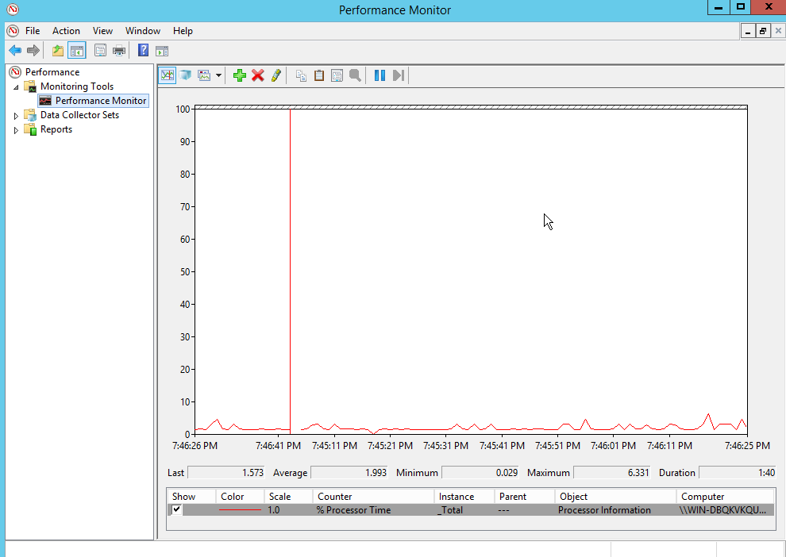

Rubric

| **Criteria** | **1 (Unsatisfactory)** | **2 (Needs Improvement)** | **3 (Satisfactory)** | **4 (Good)** | **5 (Excellent)** | **Score** |
| --- | --- | --- | --- | --- | --- | --- |

|  |  |  |  |  |  |  |
| --- | --- | --- | --- | --- | --- | --- |
| **Part 1: Setting Up Print Services** |  |  |  |  |  |  |

|  |  |  |  |  |  |  |
| --- | --- | --- | --- | --- | --- | --- |
| **Domain Installation** | No domain created | Domain created with errors | Domain created correctly | Domain configured well | Domain configured and documented thoroughly |  |

|  |  |  |  |  |  |  |
| --- | --- | --- | --- | --- | --- | --- |
| **Client Connection** | Client not connected | Connection attempt failed | Client connected but with issues | Client connected correctly | Client connected and documented well |  |

|  |  |  |  |  |  |  |
| --- | --- | --- | --- | --- | --- | --- |
| **Print Services Role Installation** | Role not installed | Role installed with issues | Role installed correctly | Role installed and configured | Role installed, configured, and documented thoroughly |  |

|  |  |  |  |  |  |  |
| --- | --- | --- | --- | --- | --- | --- |
| **Printer Installer Conversion** | No installer found | Installer conversion attempted but failed | Installer converted but not used | Installer converted and used | Installer converted, used, and documented well |  |

|  |  |  |  |  |  |  |
| --- | --- | --- | --- | --- | --- | --- |
| **Network Printer Deployment** | Printer not deployed | Deployment failed | Printer deployed but not functional | Printer deployed correctly | Printer deployed, tested, and documented well |  |

|  |  |  |  |  |  |  |
| --- | --- | --- | --- | --- | --- | --- |
| **Part 2: Monitoring Print Services** |  |  |  |  |  |  |

|  |  |  |  |  |  |  |
| --- | --- | --- | --- | --- | --- | --- |
| **Event Viewer Usage** | Event Viewer not opened | Opened but no logs reviewed | Logs reviewed but superficial | Logs reviewed with some analysis | Logs reviewed with thorough analysis and documentation |  |

|  |  |  |  |  |  |  |
| --- | --- | --- | --- | --- | --- | --- |
| **Performance Monitor Usage** | Performance Monitor not opened | Opened but no metrics monitored | Metrics monitored but not analyzed | Metrics monitored with some analysis | Metrics monitored, analyzed, and documented thoroughly |  |

|  |  |  |  |  |  |  |
| --- | --- | --- | --- | --- | --- | --- |
| **Print Management Console Usage** | Console not opened | Opened but functionality not used | Active jobs viewed superficially | Active jobs viewed with some detail | Active jobs viewed and documented thoroughly |  |

|  |  |  |  |  |  |  |
| --- | --- | --- | --- | --- | --- | --- |
| **Part 3: Exploring Third-Party Tools** |  |  |  |  |  |  |

|  |  |  |  |  |  |  |
| --- | --- | --- | --- | --- | --- | --- |
| **Research on Tools** | No tools researched | Research incomplete | Research on one tool completed | Research on two tools with some analysis | Research on two tools, detailed analysis, and comparison |  |

|  |  |  |  |  |  |  |
| --- | --- | --- | --- | --- | --- | --- |
| **Installation and Configuration** | Tool not installed | Installation failed | Tool installed but not configured | Tool installed and configured with issues | Tool installed, configured, and documented thoroughly |  |

|  |  |  |  |  |  |  |
| --- | --- | --- | --- | --- | --- | --- |
| **Reporting Findings** | No report generated | Report lacks detail | Report generated but lacks analysis | Report generated with some analysis | Comprehensive report with thorough analysis and documentation |  |